Flipkart OTP Login Test

import re
import subprocess
import time
from selenium import webdriver
from selenium.webdriver.common.by import By
from selenium.webdriver.support.ui import WebDriverWait
from selenium.webdriver.support import expected_conditions as EC
from selenium.common.exceptions import TimeoutException, StaleElementReferenceException

URL = "https://www.flipkart.com/login"
MOBILE = "7708176597"

NON_SEARCH_INPUTS = "//input[not(@name='q') and not(@type='hidden') and not(@disabled)]"
CONTINUE_BTN = (By.XPATH, "//button[contains(.,'Continue') or contains(.,'Request OTP')]")
VERIFY_BTN = (By.XPATH, "//button[contains(.,'Verify') or contains(.,'Login') or contains(.,'Continue')]")

def adb_ready():
try:
out = subprocess.run(["adb", "devices"], capture_output=True, text=True).stdout
except FileNotFoundError:
return False
return any(line.endswith("device") for line in out.splitlines()[1:])

def otp_from_phone(after_ts, timeout=60):
end = time.time() + timeout
while time.time() < end:
out = subprocess.run(
["adb", "shell", "content", "query", "--uri", "content://sms/inbox",
"--projection", "body,date", "--sort", "date DESC"],
capture_output=True, text=True
).stdout
for line in out.splitlines():
if "flipkart" in line.lower():
d = re.search(r"date=(\d+)", line)
m = re.search(r"\b(\d{6})\b", line)
if d and m and int(d.group(1)) / 1000 >= after_ts:
return m.group(1)
time.sleep(2)
return None

def get_otp(after_ts):
if adb_ready():
return otp_from_phone(after_ts)
value = input("Type the 6-digit OTP from your phone: ").strip()
return value if re.fullmatch(r"\d{6}", value) else None

def visible_inputs(driver):
return [e for e in driver.find_elements(By.XPATH, NON_SEARCH_INPUTS) if e.is_displayed()]

def dump_inputs(driver):
for e in driver.find_elements(By.TAG_NAME, "input"):
print(e.get_attribute("outerHTML"))

options = webdriver.ChromeOptions()
options.add_argument("--disable-blink-features=AutomationControlled")

driver = webdriver.Chrome(options=options)
driver.maximize_window()
wait = WebDriverWait(driver, 20, ignored_exceptions=(StaleElementReferenceException,))
results = {}

try:
driver.get(URL)

wait.until(lambda d: len(visible_inputs(d)) > 0)
phone = visible_inputs(driver)[0]
driver.execute_script("arguments[0].scrollIntoView({block:'center'});", phone)
phone.click()
phone.send_keys(MOBILE)

search_value = driver.find_element(By.NAME, "q").get_attribute("value")
results["mobile entered"] = phone.get_attribute("value") == MOBILE and search_value == ""

if not results["mobile entered"]:
print("Inputs found on page:")
dump_inputs(driver)
else:
requested_at = time.time()
wait.until(EC.element_to_be_clickable(CONTINUE_BTN)).click()

try:
wait.until(lambda d: [e for e in visible_inputs(d) if e.get_attribute("value") == ""])
otp_field = [e for e in visible_inputs(driver) if e.get_attribute("value") == ""][0]
results["otp requested"] = True
except TimeoutException:
results["otp requested"] = False

if results["otp requested"]:
otp = get_otp(requested_at)
results["otp received"] = otp is not None

if otp:
otp_field.click()
otp_field.send_keys(otp)
try:
wait.until(EC.element_to_be_clickable(VERIFY_BTN)).click()
except TimeoutException:
pass
try:
wait.until(lambda d: "/login" not in d.current_url)
results["login verified"] = True
except TimeoutException:
results["login verified"] = False

except Exception as e:
results["error"] = str(e).splitlines()[0]
try:
dump_inputs(driver)
except Exception:
pass

finally:
driver.quit()

for step, status in results.items():
print(f"{step}: {status}")

print("TEST PASSED" if results.get("login verified") is True else "TEST FAILED")

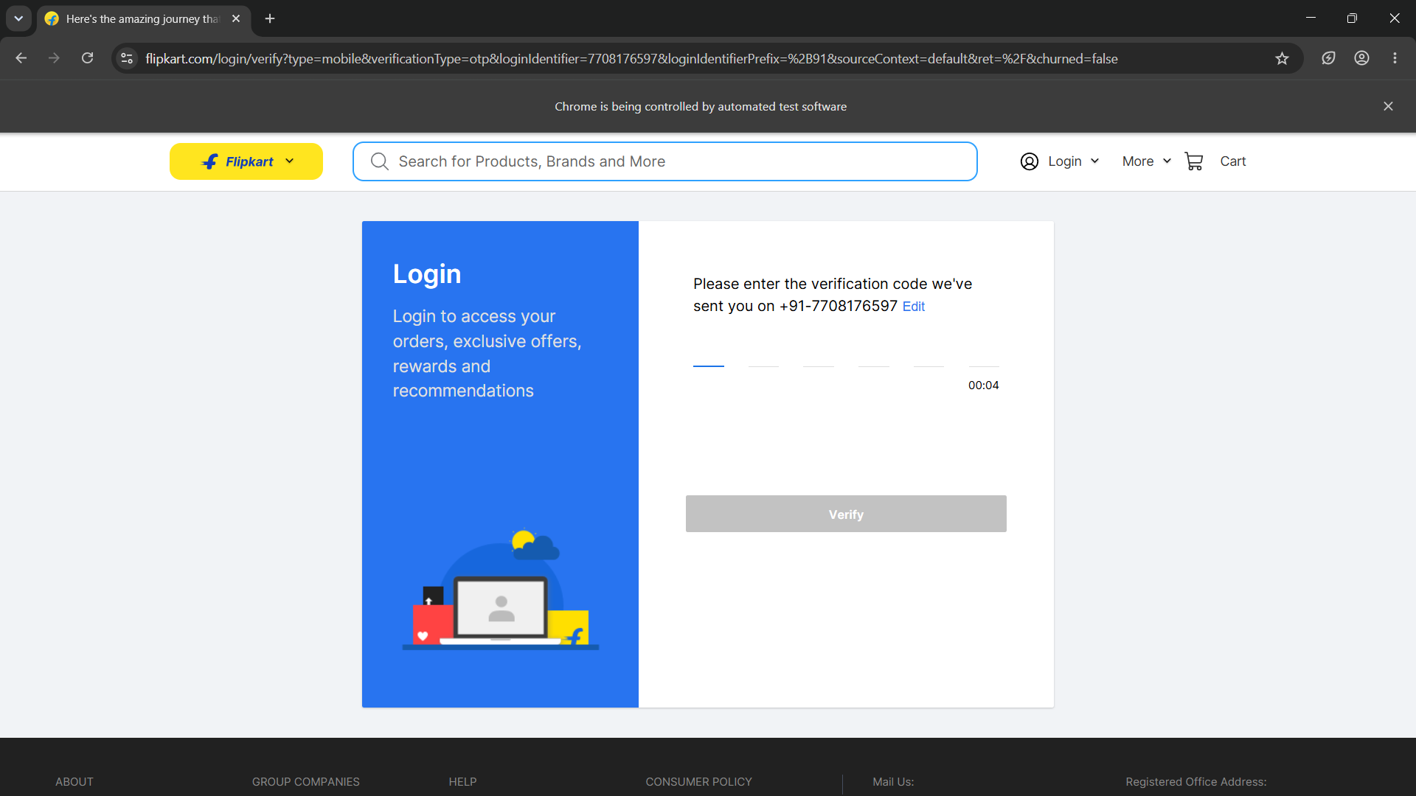

Website Login Test

from selenium import webdriver
from selenium.webdriver.common.by import By
from selenium.webdriver.common.keys import Keys
from selenium.webdriver.chrome.options import Options
from selenium.webdriver.support.ui import WebDriverWait
from selenium.webdriver.support import expected_conditions as EC
import time

chrome_options = Options()

chrome_options.add_experimental_option("detach", True)

chrome_options.add_argument("--guest")
chrome_options.add_argument("--disable-blink-features=AutomationControlled")

driver = webdriver.Chrome(options=chrome_options)

try:

driver.get("https://images.google.com")

search_box = driver.find_element(By.NAME, "q")
search_box.send_keys("actor suriya" + Keys.ENTER)

WebDriverWait(driver, 10).until(
EC.presence_of_element_located((By.XPATH, "//div[@role='listitem']//img | //img[@data-deferred='1']"))
)

print("True")

time.sleep(3)

finally:

driver.quit()

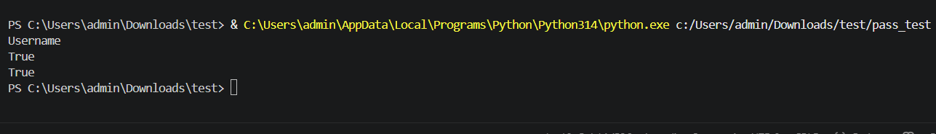

Check the product in site:

from selenium import webdriver
from selenium.webdriver.common.by import By
from selenium.webdriver.support.ui import WebDriverWait
from selenium.webdriver.support import expected_conditions as EC
import time # 1. Imported the time module for the delay

# Initialize the Chrome driver normally
driver = webdriver.Chrome()

# Navigate to the website
driver.get("https://saucedemo.com")

# Locate elements
username = driver.find_element(By.ID, "user-name")
password = driver.find_element(By.NAME, "password")
login = driver.find_element(By.ID, "login-button")

# Interact with the elements
username.send_keys("standard_user")
password.send_keys("secret_sauce")

# Click the login button
login.click()

print("\n--- Logging in... ---")

try:
# 2. Wait until the inventory page successfully loads
WebDriverWait(driver, 10).until(
EC.presence_of_element_located((By.CLASS_NAME, "inventory_list"))
)

# 3. Locate all the product titles on the screen
products = driver.find_elements(By.CLASS_NAME, "inventory_item_name")

# 4. Print the product catalog to your console
print(f"\nSuccessfully logged in! Found {len(products)} products on the screen:\n")
for index, item in enumerate(products, start=1):
print(f"{index}. {item.text}")

# 5. PAUSE FOR 5 SECONDS: Keeps the page fully visible on your screen
print("\nKeeping the product page open for 5 seconds...")
time.sleep(3)

finally:
# 6. AUTOMATICALLY CLOSE: Shuts down the browser after the 5-second wait
print("Closing the browser automatically now.")
driver.quit()

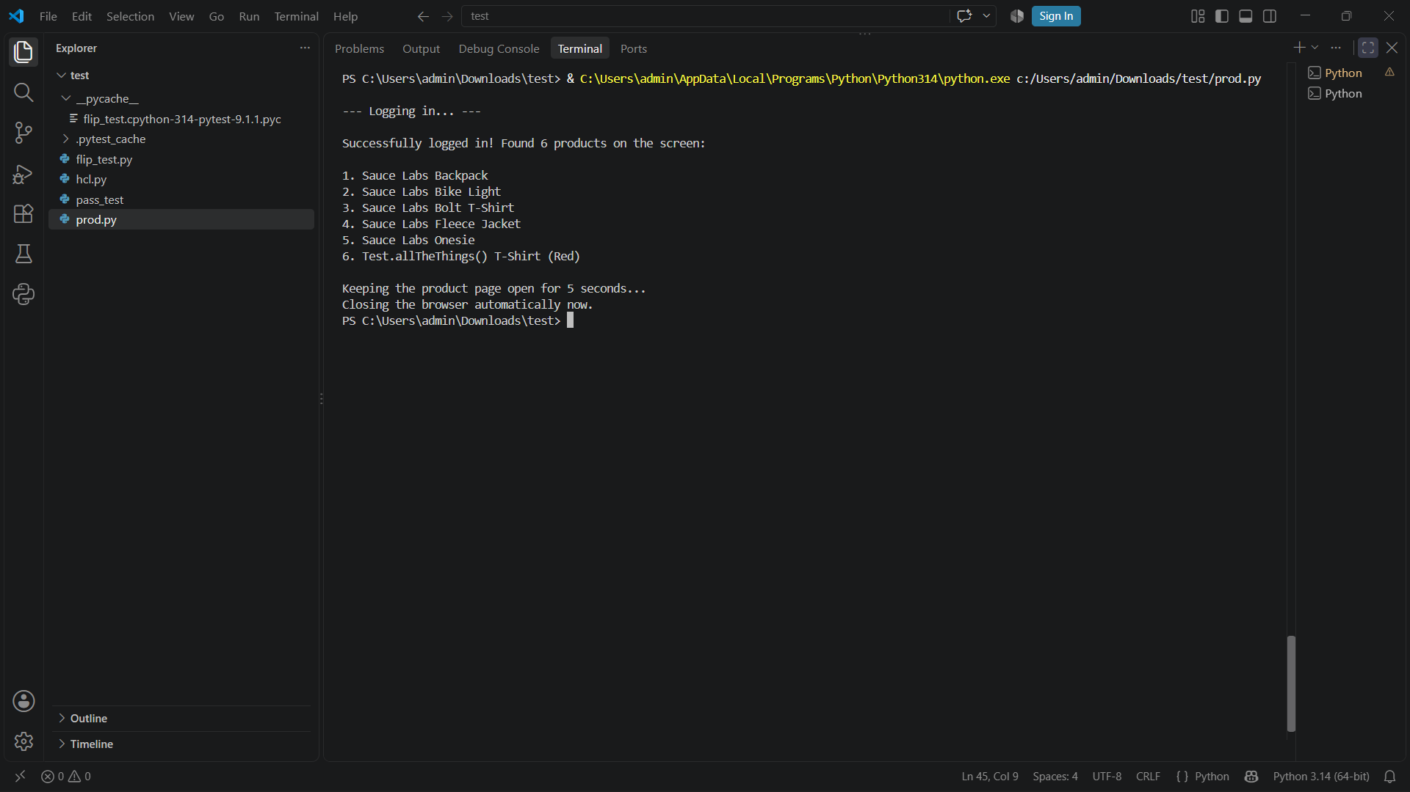

Google Search for Actor Suriya
from selenium import webdriver
from selenium.webdriver.common.by import By

driver = webdriver.Chrome()
driver.get("https://saucedemo.com/")

username = driver.find_element(By.ID, "user-name")
password = driver.find_element(By.NAME, "password")
login = driver.find_element(By.ID, "login-button")
username.send_keys("standard_user")
password.send_keys("secret_sauce")

print(username.get_attribute("placeholder"))
print(login.is_enabled())
print(username.is_displayed())

# Click the login button
login.click()

